CSE-2015 Data analysis and visualization report

Mini Project

Suicide Etiology

Team members:

Hitesh D: 20211IST0023

Shamitha R: 20211IST0020

Sushmitha V M:20211IST0026

Abstract: Understanding Suicide Trends Through Data Visualization

Suicide remains a profound global public health concern, necessitating comprehensive analysis and targeted interventions. This abstract presents a detailed exploration of suicide trends using data visualization techniques. Leveraging datasets sourced from reputable sources, this study employs various visualization methods to uncover intricate patterns, disparities, and potential influencing factors associated with suicide rates.

The analysis begins with a broad overview of global suicide rates, utilizing barplot, lineplot,lm plot, pie charts and other plots. Through these visualizations, regions with alarmingly high or low suicide rates are identified, serving as focal points for further investigation and intervention efforts.

Moving beyond global trends, demographic analysis offers insights into the differential impact of suicide across various age groups and genders. Bar charts and pie charts are employed to highlight disparities in suicide rates, shedding light on vulnerable populations and potential risk factors unique to different demographic segments.

Regional analysis further enriches our understanding by exploring localized patterns and contextual factors contributing to suicide rates.

The Implications of these findings are profound. By harnessing the power of data visualization, policymakers, healthcare professionals, and stakeholders can tailor interventions to address the specific needs of high-risk populations and regions. Targeted prevention programs, increased access to mental health services, and efforts to mitigate socio-economic disparities emerge as key recommendations derived from the analysis.

PROBLEM STATEMENT

Suicide remains a significant public health concern, with devastating consequences for individuals, families, and communities. Understanding the trends and patterns in suicide rates is essential for developing effective prevention strategies and interventions.

**Introduction to Data Visualization: Understanding Suicide Statistics**

In recent years, the issue of mental health and suicide prevention has gained increasing attention worldwide. Understanding the prevalence, trends, and underlying factors associated with suicide is crucial for developing effective prevention strategies and support systems. Data visualization plays a pivotal role in this endeavor, offering powerful tools to analyze, interpret, and communicate complex suicide statistics in a meaningful and accessible manner.

**Scope of the Report**

This report explores the use of data visualization techniques to elucidate suicide statistics, shedding light on key trends, patterns, and disparities across different demographic groups, geographical regions, and time periods. By harnessing the power of visual representations, we aim to enhance understanding, raise awareness, and facilitate evidence-based decision-making in the realm of suicide prevention and mental health advocacy.

**Importance of Data Visualization**

Data visualization transcends traditional tabular formats by transforming raw data into visual representations such as charts, graphs, maps, and infographics. These visualizations not only convey information more intuitively but also facilitate rapid comprehension and insight generation. In the context of suicide statistics, data visualization enables stakeholders to identify trends, detect outliers, and uncover underlying relationships that may not be immediately apparent in raw data tables.

**Key Objectives**

The primary objectives of this report are as follows:

1. **Highlighting Trends**: Utilizing data visualization techniques to illustrate trends and patterns in suicide rates, methods, and demographic characteristics over time.
2. **Exploring Disparities**: Examining disparities in suicide rates across different demographic groups, including age, gender, ethnicity, socioeconomic status, and geographic location.
3. **Identifying Risk Factors**: Identifying risk factors and correlates associated with suicide through visual analysis of relevant datasets, such as mental health indicators, substance abuse prevalence, and access to healthcare services.
4. **Informing Policy and Practice**: Providing insights and recommendations for policymakers, public health officials, and mental health practitioners based on data-driven visualizations of suicide statistics.

Visualization 1:Yearwise Total suicides

In this visualization we have Plotted the graph where total number of suicides is predicted in each year .

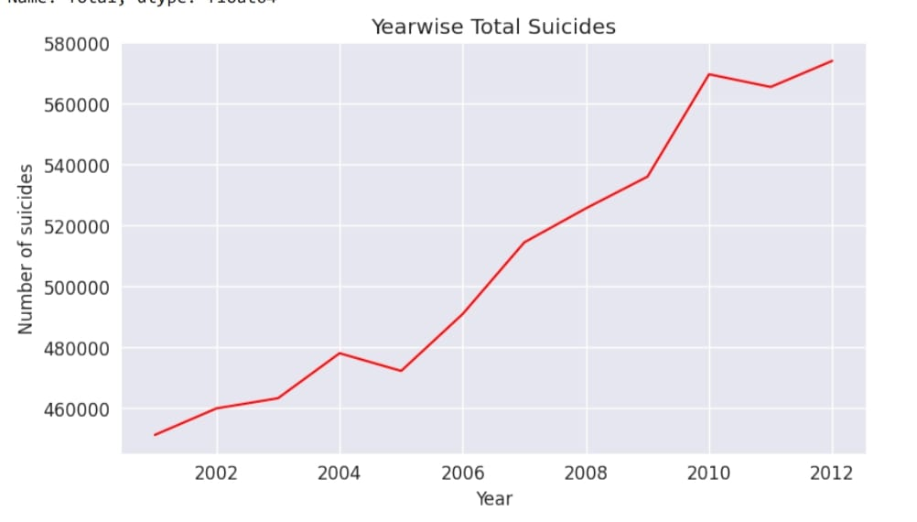

Visualization 2: Total number of suicides in each state

In here, we have visualized the total number of deaths in the recent years in each state

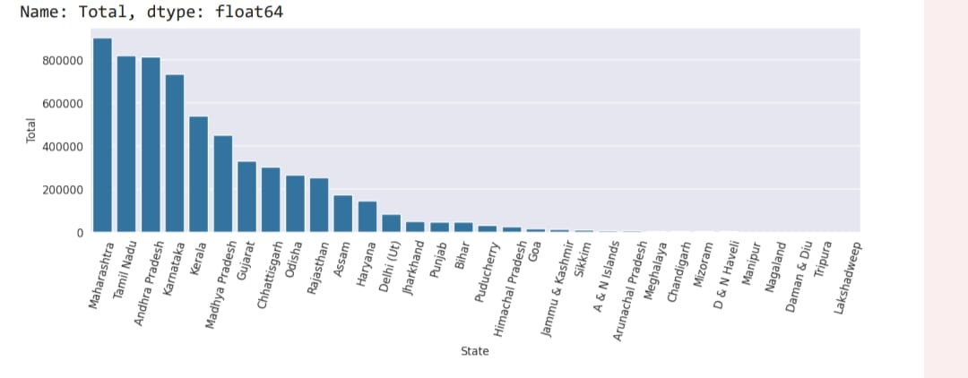

Visualization 3:Suicide according to causes in each year

Here the visualization is done with respect to the causes of which so many deaths have taken place.

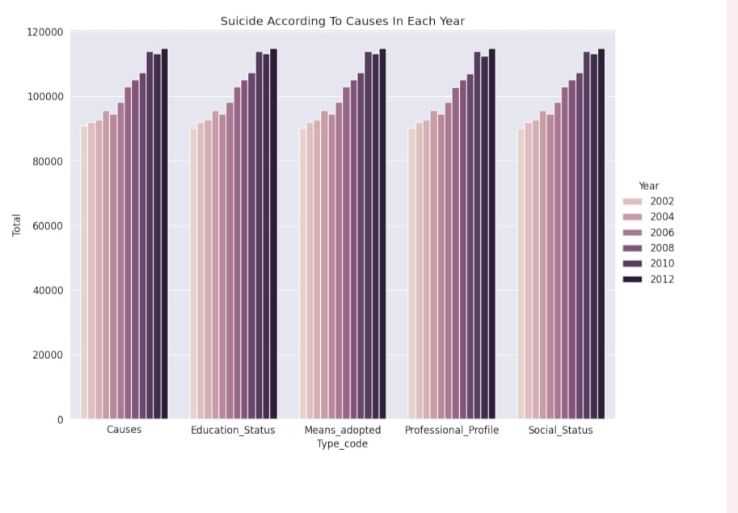

Visualization 4: Pie Chart Showing Suicide Rates by Gender

This pie chart shows the number of deaths for male is to female

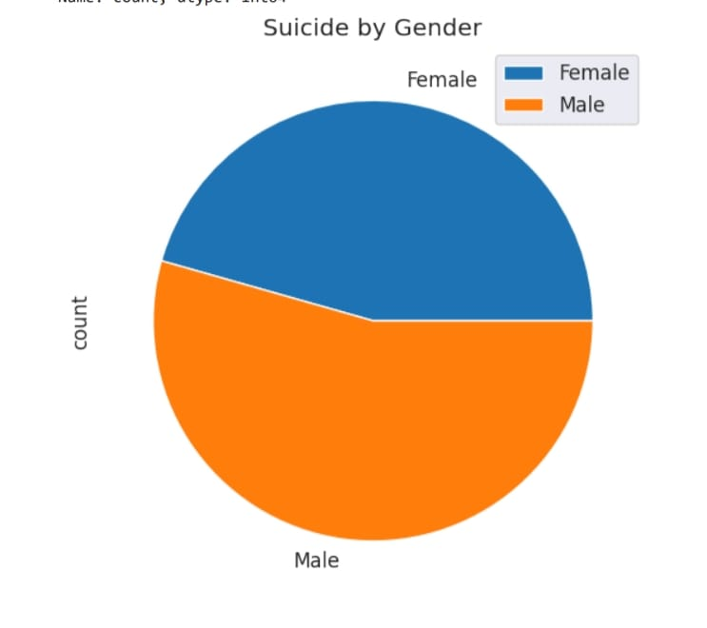

Visualization 5: Bar chart showing suicide according to educational Status.

This visualization is used to plot the number of people with what educational status have committed suicide using bar chart.

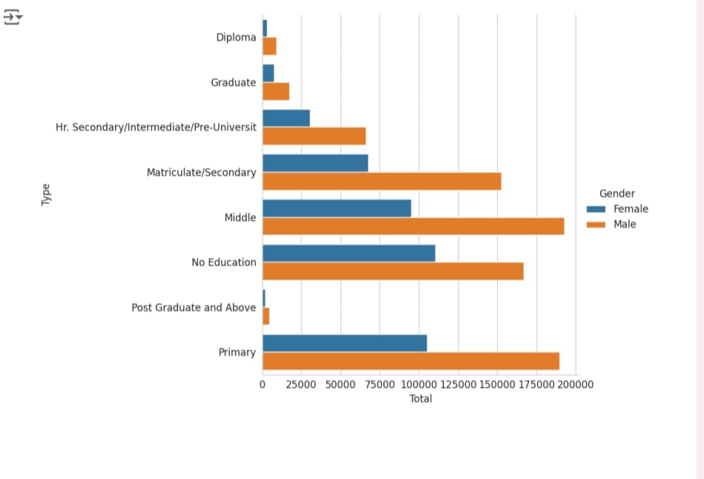

Visualization 6: Line plot showing the suicide rates according to social status.

This plot tell us how many people with what social status have committed suicide using lineplot.

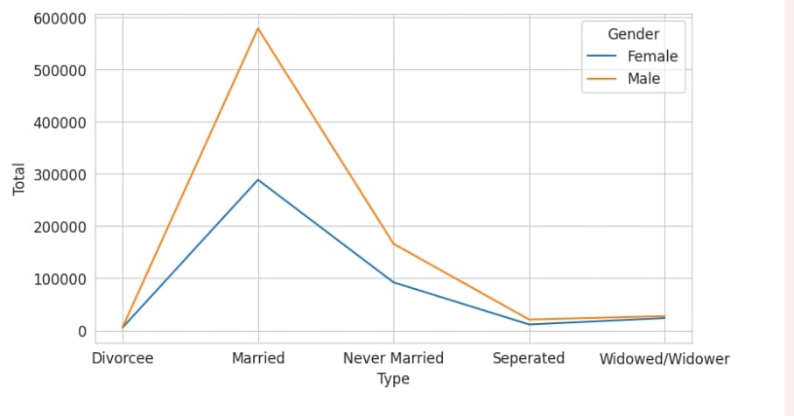

Visualization 7: Bar plot showing suicide rates according to age distributions.

This plot briefs us about how many people within what age group have committed suicide using bar plot.

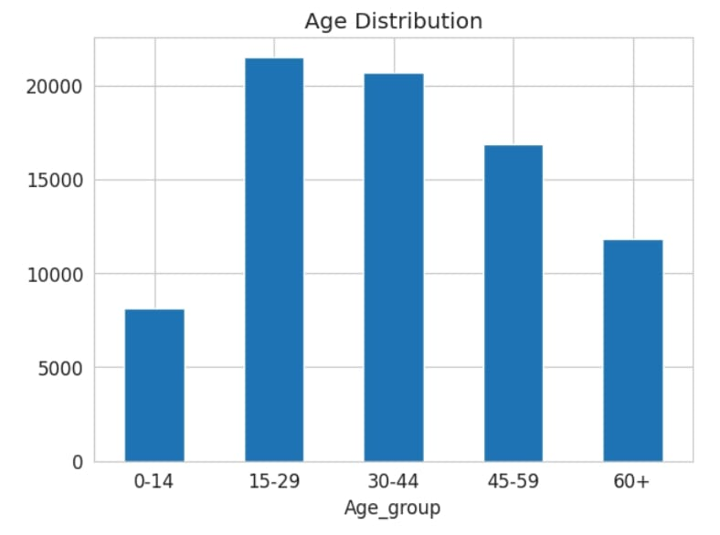

Visualization 8: lm plot showing suicide rates according to year and gender.

Lm plot is used to tell us how many people with which gender and in which years have committed suicide.

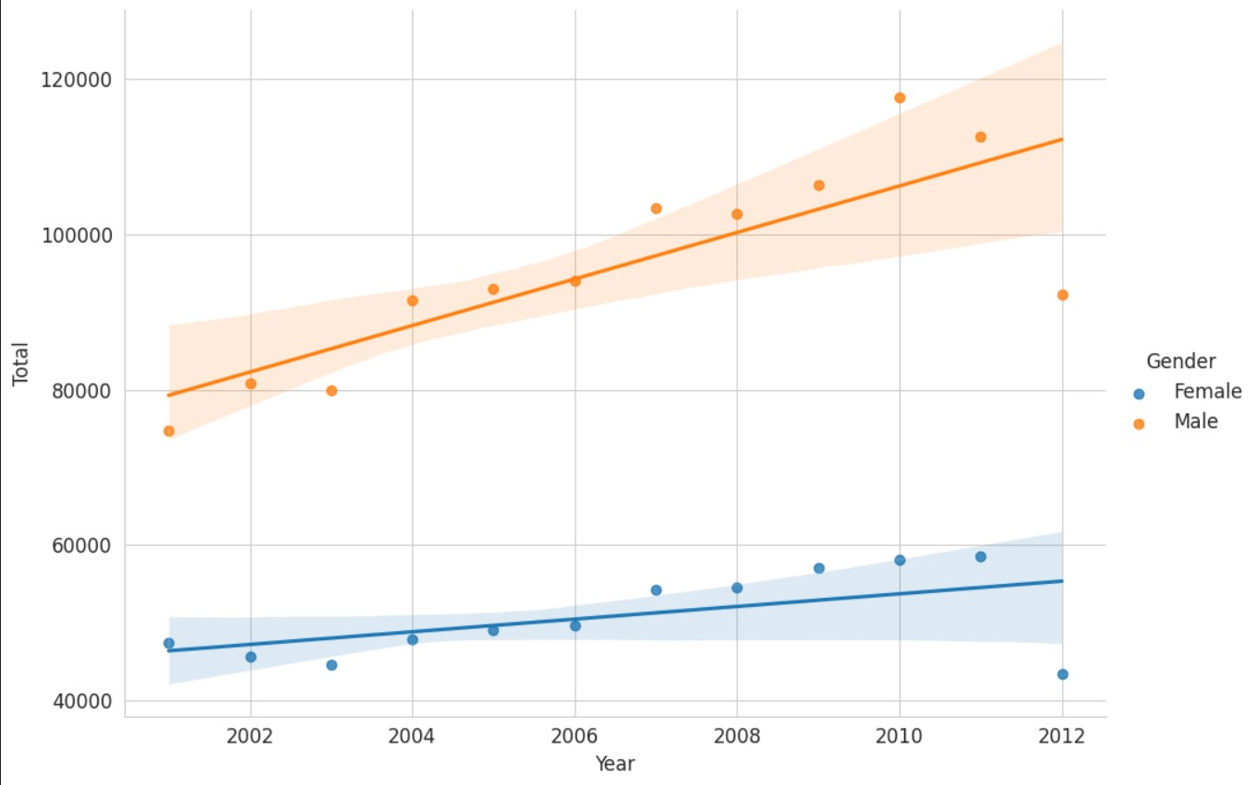

CONCLUSION

Analyzing suicide etiology using data analysis and visualization involves examining various factors such as demographics, socio-economic status, mental health conditions, and environmental influences to understand their relationship with suicide rates.

Understanding the trends and patterns in suicide rates is essential for developing effective prevention strategies and interventions.

*In this project, we achieved a cleaned dataset of the Suicide entiology data which can be used for visualization.

By performing visualization we can to know about many insights about suicide rates which can be used to improve prevention strategies .

We discovered :

-the state which has maximum Suicide rates

-the year recorded highest suicide rate

-the different causes for suicide

-the main causes for suicide

-Comparing gender which recorded highest suicide rate

-the Suicide rate cause -wise

-the number of suicides that happened each year.